WEB TECHNOLOGIES

LAB TASK 11



Submitted by: TAHIR AHMED KHAN

Registration No: SP21-BSE-086

Class Section: 6B

Submitted to: SIR HASNAIN IQBAL

Department of computer science

Comsats University Islamabad

**Lab Task 1:**

<!DOCTYPE html>

<html lang="en">

<head>

    <meta charset="UTF-8">

    <meta name="viewport" content="width=device-width, initial-scale=1.0">

    <title>Document</title>

    <style>

        img{

            display: none;

        }

    </style>

</head>

<body>

    <img id="a" src="https://www.sellerapp.com/blog/wp-content/uploads/2020/07/amazon-advertising-ad-types.png" alt="Sale" height="400px" width="600px">

    <script>

**var** settime **=** setTimeout(func, 3000);

**function** func(){

            document.getElementById("a").style.display **=** 'block';

        }

    </script>

</body>

</html>

**Output:**

Before:

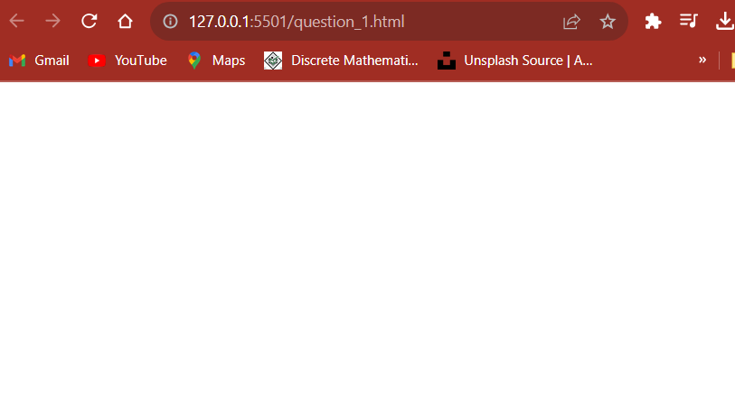

After 3 seconds:

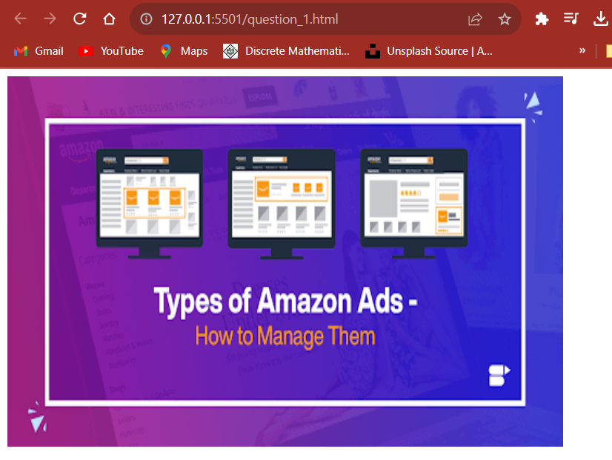

**Lab Task 2:**

<!DOCTYPE html>

<html lang="en">

<head>

    <meta charset="UTF-8">

    <meta name="viewport" content="width=device-width, initial-scale=1.0">

    <title>Document</title>

    <style>

        #a{

            border: 2**px** solid black;

            padding: 8**px**;

            display: inline;

            background-color: blue;

        }

    </style>

</head>

<body>

    <div>

        <br>

        <p id="a">Tahir Ahmed Khan SP21-BSE-086</p>

        <br><br>

        <button onclick="stop()">Stop Now</button>

    </div>

    <script>

**const** myInterval **=** setInterval(func, 3000);

**function** func(){

**let** element **=** document.getElementById("a");

**let** color **=** element.style.backgroundColor;

**if** (color **==** 'blue'){

                element.style.backgroundColor **=** 'green';

            }

**else**{

                element.style.backgroundColor **=** 'blue';

            }

        }

**function** stop(){

            clearInterval(myInterval);

        }

    </script>

</body>

</html>

**Output:**

Before:



After 3 seconds:

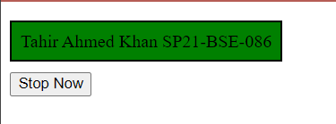

Note: Now if I click “Stop Now” then color will not change again.

